PADFLASH
Update Guide

VERSION  1.02 | RELEASE  2025 | OS SUPPORT  Win 7 / 10 / 11 | INCLUDES  MEDC17 Checksum Fix

What's New in v1.02

Improvement | Details
OS Compatibility | Full support for Windows 7 (SP1), Windows 10, and Windows 11 — 32 & 64-bit.
MEDC17 Checksum Fix | Resolved checksum calculation errors on MEDC17 ECU read/write operations.
USB Stability | Improved reconnection logic — significantly reduces 'Connection Lost' occurrences.
Driver Signing (SHA-256) | Super Driver updated with valid Microsoft signatures for Win10/11 enforcement.
Connection Lost Solution | New bundled utility to disable USB sleep and manage antivirus/firewall for ECU sessions.
Security Dongle Detection | Faster dongle enumeration on USB 3.0 hubs; fallback to USB 2.0 protocol on legacy systems.

System Requirements

Operating System | Windows 7 SP1 · Windows 10 · Windows 11 (32-bit & 64-bit)
USB | Powered USB 2.0 or USB 3.0 hub (mandatory — direct port may cause instability)pacakge come with usb 2.0 hub
RAM | 2 GB minimum · 4 GB recommended
Storage | 500 MB free disk space for installer and firmware cache
Permissions | Administrator account required for driver installation and launch
Security Dongle | Must be connected to the same USB hub as the Padflash device at startup

Hardware Connection — Live Diagram

Connect all devices to the powered USB hub before launching any driver tool or Padflash V2.

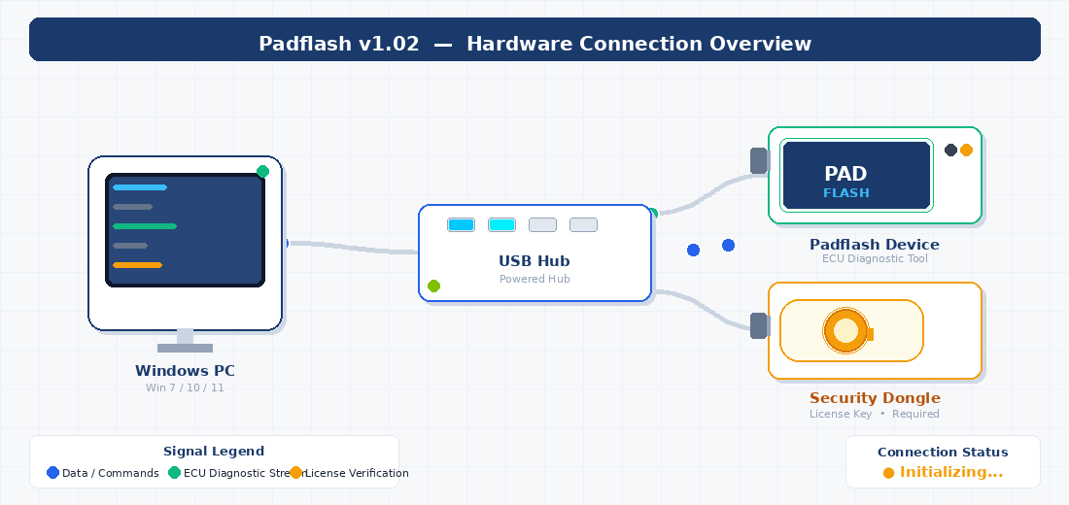

■ PC → Hub  Command & data stream | ■ Hub → Padflash  ECU diagnostic channel | ■ Hub → Dongle  License verification

Step-by-Step Installation Procedure

Read all phases before starting. Complete steps in order — skipping any step may cause device connection failures.

PHASE 1 — SOFTWARE UPDATE
01 | Uninstall previous Padflash software  Control Panel → Programs & Features → Padflash → Uninstall
02 | Install Padflash Updater  Run PadflashUpdater_Setup.exe with Administrator privileges
03 | Update to Version 1.02  Open Padflash Updater → click Update → wait for full download
04 | Download firmware & restart Updater  Confirm download completes, then close and reopen Padflash Updater
PHASE 2 — HARDWARE & DRIVER SETUP
05 | Connect Padflash device to USB Hub  Plug device USB cable into any port on the powered hub
06 | Connect Security Dongle to USB Hub  Plug dongle into a separate port on the same powered hub
07 | Run Super Driver as Administrator  Right-click superdriver.exe → Run as Administrator
08 | Click Install Driver inside Super Driver  Wait for the success notification before continuing
09 | Install driver via Padflash Driver Tool  Open Padflash Driver → Install → accept all prompts
PHASE 3 — SYSTEM CONFIGURATION
10 | Run Padflash Connection Lost Solution  Right-click the utility shortcut → Run as Administrator
11 | Disable USB Sleep / Power Management  Click 'Disable USB Sleep' inside the tool → confirm
12 | Acquire Administrator Rights  Click 'Gain Admin Rights' → allow UAC prompt
13 | Disable Antivirus & Firewall  Click 'Disable AV & Firewall' — re-enable after testing
PHASE 4 — FINAL LAUNCH
14 | Reboot the computer  Full shutdown and cold restart — mandatory, do not skip
15 | Open Padflash Updater after reboot  Confirm version 1.02 is shown in the title bar
16 | Launch Padflash V2 as Administrator  Desktop icon → right-click → Run as Administrator → ready

Installation Flowchart

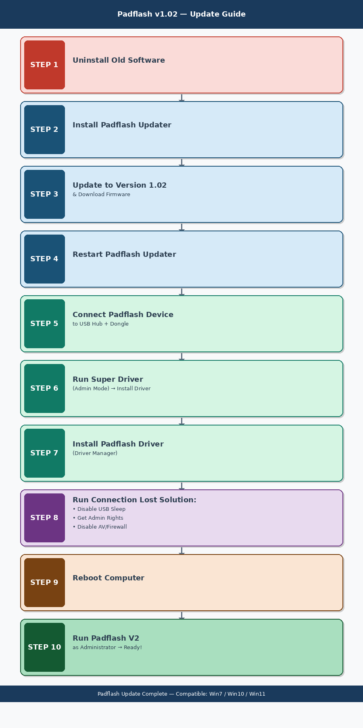

Troubleshooting

Symptom | Recommended Action
Device not detected | Reconnect device and dongle to hub. Re-run Super Driver. Reinstall Padflash Driver.
Connection Lost error | Run Connection Lost Solution → Disable USB Sleep → Reboot.
Driver install fails | Temporarily disable Defender & antivirus. Always run Super Driver as Administrator.
MEDC17 checksum error | Ensure v1.02 is installed — the MEDC17 fix is exclusive to this release.
Software won't launch | Always right-click Padflash V2 → Run as Administrator.
Windows 7 compatibility | Ensure SP1 is installed. Run sfc /scannow from an admin command prompt if drivers fail.
Dongle not recognized | Connect dongle directly to the powered USB hub. Avoid extension cables.

Support

If issues persist after completing all steps, contact your authorized Padflash reseller with your device serial number and a screenshot of the error message.

Always launch Padflash V2 via Run as Administrator. Failure to do so is the leading cause of connection and licensing errors.

