No. | Category | (ADS) ADS 1500 Oil Service Reset Tool | X-200
1 | Picture | 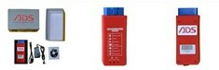 | 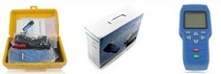
2 | Weight & specification | Small size, 0.38KG, 145*95*90mm | Big size, 1.4KG, 301*210*100MM
3 | Portability | Only need to carry an interface that can communicate with phones via Bluetooth | Need to carry a 1.5KG case containing the device and cables.
4 | System support | Android phone, Win7 PC and Windows XP PC | Hand-held device, does not support phone or PC
5 | Methods of communication | Bluetooth or USB cable | Main cable and OBD port cable
6 | Update | Free online update | Take out TF card and use TF card reader to read and renew software
7 | Upgrade cost | Lifetime free updates | Free updates
8 | Special function | Record, save and print OBD diagnostic procedure and result on PC, and save the files in PDF format | No special function
9 | Screen size | Phone and PC screens are bigger and allows users to see more content | Built-in screen is smaller and can fit less content on it

