Multidiag access J2534 Comparison Table

Content | V2011 Multi-Di@g Access (SP04-C) | Multi-Diag Access 2013V(SP04-D) | Multi-Di@g Access V2013.02 (SP04-G)
Version | 2011 | 2013.1 | V2013.02
OS | Win XP and Win 7 | Win XP and Win 7 | Win XP and Win 7 32bit(only 32bit)
Language | Multilanguage | Multilanguage | Multilanguage
ID format for activation
 | 23-XXXXXXXXCVD | 27-XXXXXXXXYKF | 28-XXXXXXXXYKF
Installation | Video tutorial:  放视频地址 | Video tutorial:  放视频地址 | Video tutorial:  放视频地址
Function | Maintenance  Brakes, wheels and suspension  Battery  Air-Conditioning  Body and windshield  Equipment  Anti-pollution and exhaust system  Engine Diagnose  Expert mode

Note: the newer the Multidiag actia version is, the more car models it supports, and newer it can work with. As for what ECU type Multidiag actia support, it depends on specific car models and year, after finish installation, you will see the detailed car models, years and ECU types in the Multi-Diag software.

Take Multi-Diag Access V2013.2 for example, it supports more car models and newer cars shown as follows.
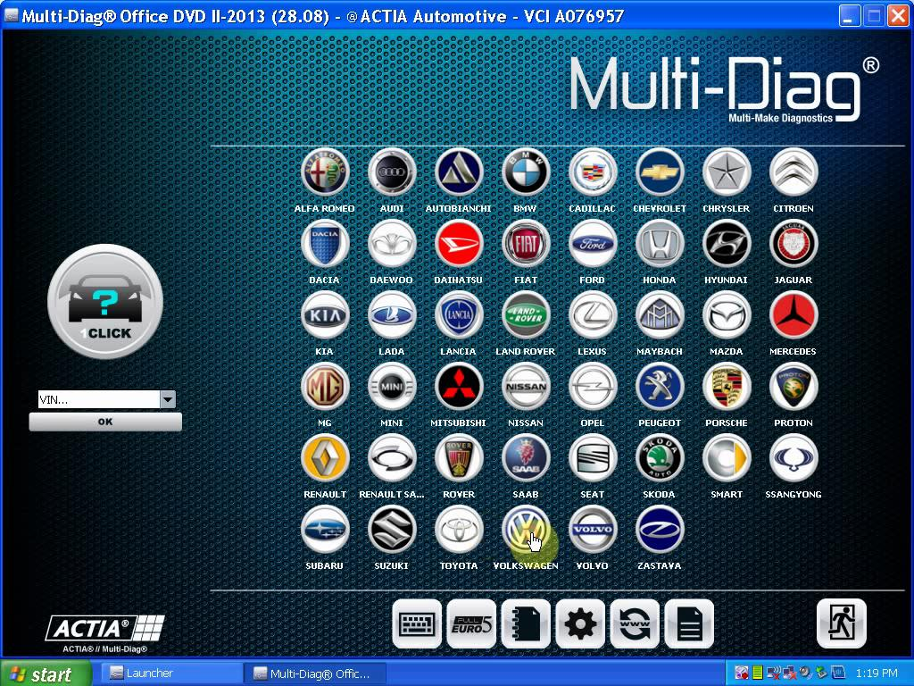
Multi-Diag Access V2013.2 supported car list

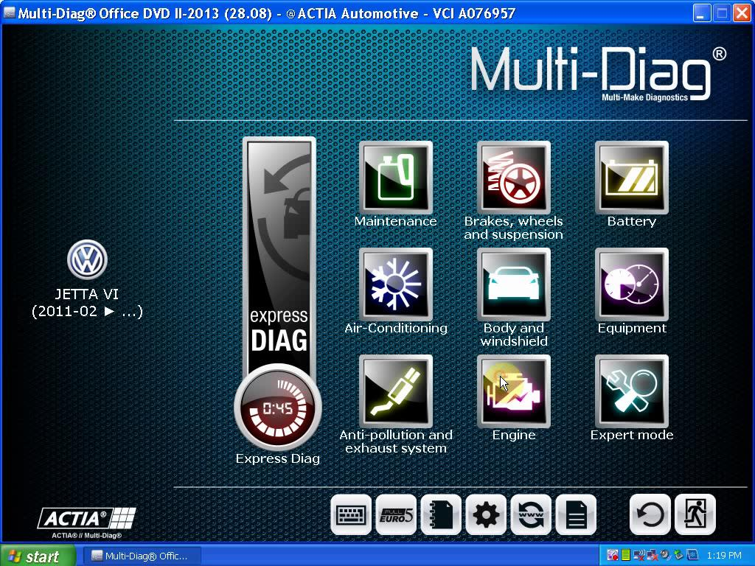
Multi-Diag Access V2013.2 function

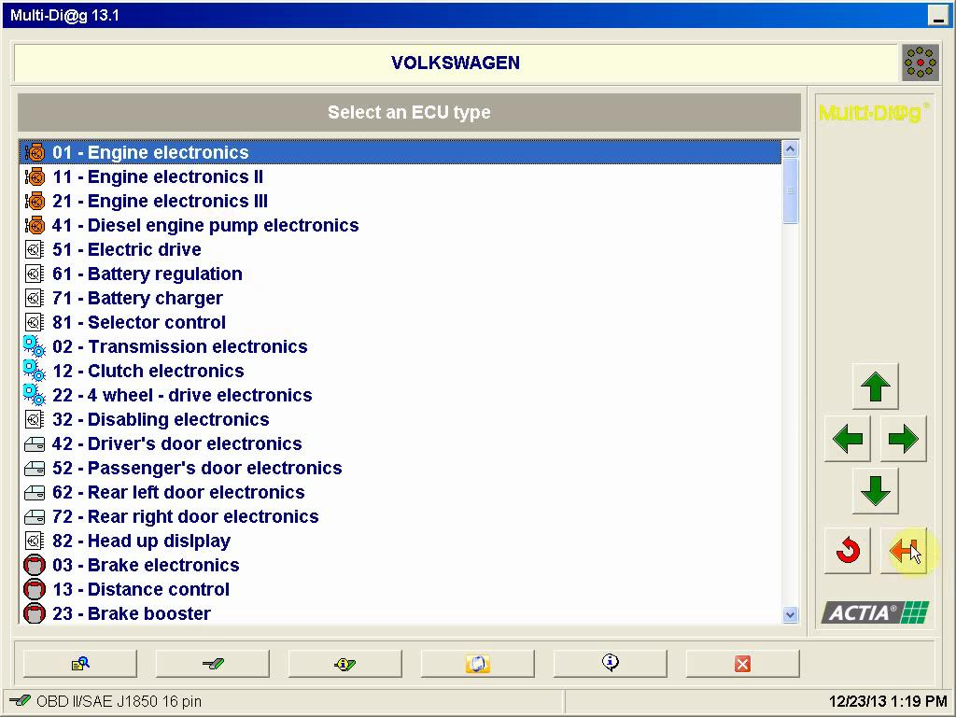
Multi-Diag Access V2013.2 supported Volkswagen ECU type

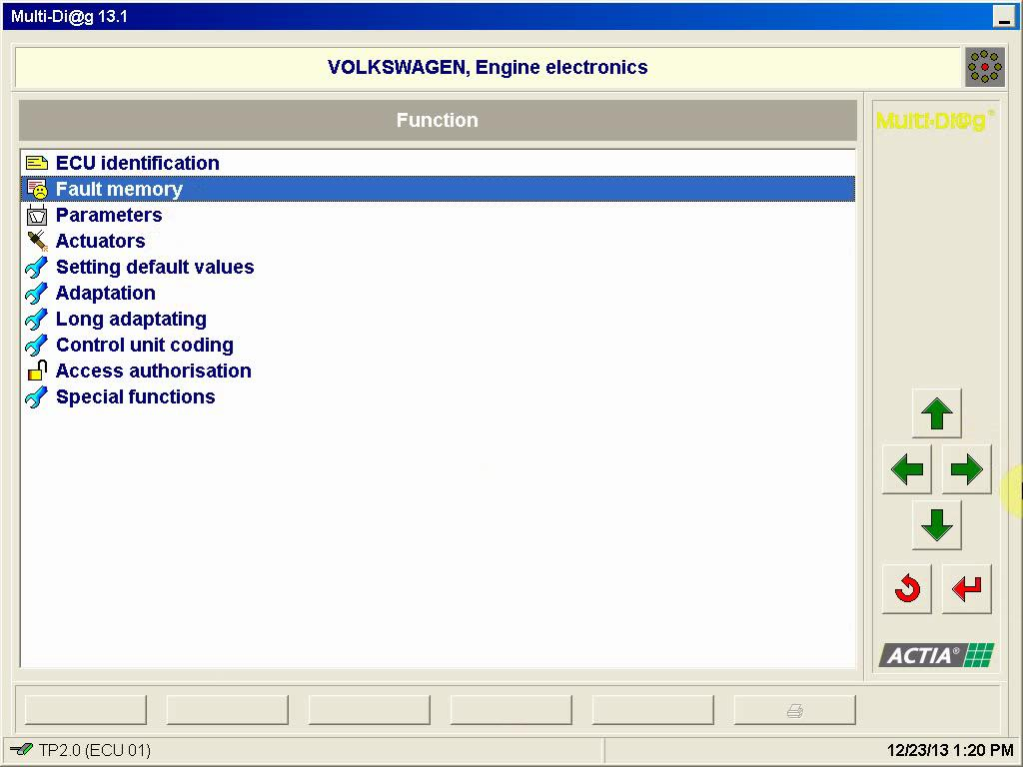
Multi-Diag Access V2013.2 delete fault code

